Pre-Lab 3: Node Analysis Methods

Node Analysis

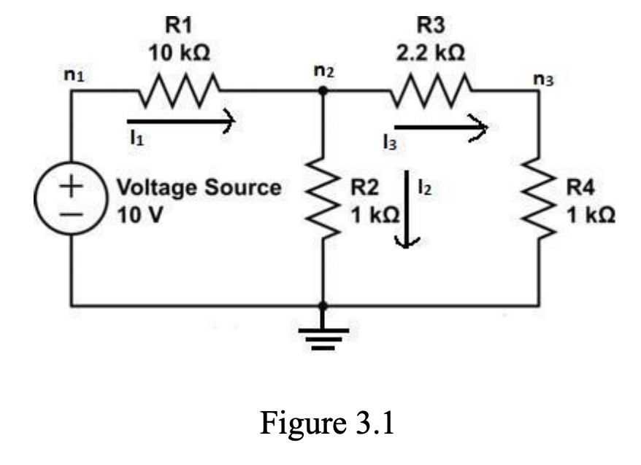
- The voltage across resistor $R_{4}$ is $V_{4}=V_{2}\frac{1 \text{kΩ}}{3.2 \text{k}\text{Ω}}$
- Voltages $n_{i}$and currents $I_{k}$
  - $R_{34}=3.2 \text{kΩ}, R_{p}=R_{342}=\frac{1}{\frac{1}{3.2 \text{kΩ}}+1 \text{kΩ}}=0.762 \text{kΩ}$, and $R_{eq}=10.767 \text{kΩ}$
  - $I_{1}=\frac{V_{s}}{R_{eq}}=929 \text{μA}⇒$ $I_{1}=I_{2}+I_{3}=\frac{n_{2}}{1 \text{kΩ}}+\frac{n_{2}}{3.2 \text{kΩ}}⇒n_{2}=V_{2}=\frac{I_{1}}{\frac{1}{3.2 \text{kΩ}}+1 \text{kΩ}}=708 \text{mV}$.
  - $I_{1}=929 \text{μA}$, $I_{2}=\frac{708 \text{mV}}{1 \text{kΩ}}=708 \text{mA}$, $I_{3}=\frac{708 \text{mV}}{3.2 \text{kΩ}}=221 \text{μ}\text{A}$
  - $n_{1}=10 \text{V}\text{, }n_{2}=708 \text{mV}$, $n_{3}=V_{4}=n_{2}\left(\frac{1 \text{kΩ}}{3.2 \text{k}\text{Ω}}\right)=221 \text{mV}$
- 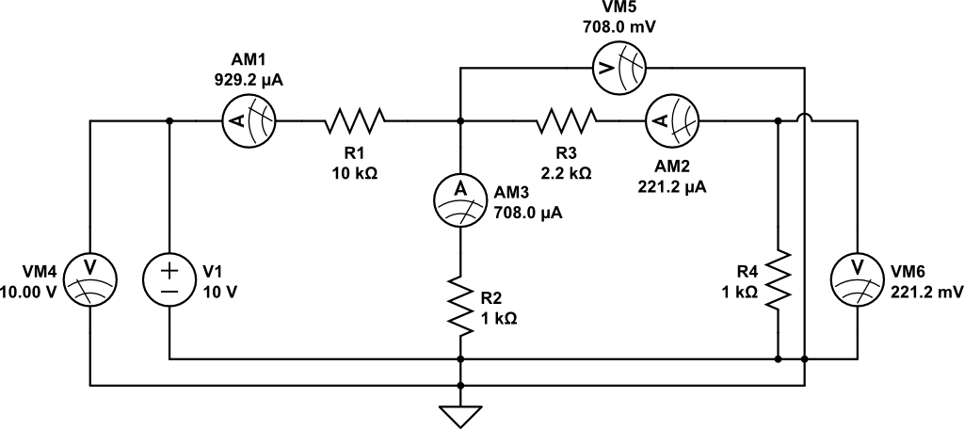

Nodal Analysis with Current-Dependent Voltage Source

